

**WhatsApp – Messaging and Location Sharing**

**iTunes Store URL:** <https://itunes.apple.com/au/app/whatsapp-messenger/id310633997?mt=8>

**Screenshots:**

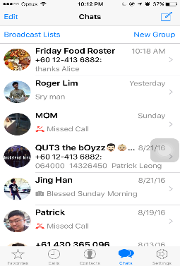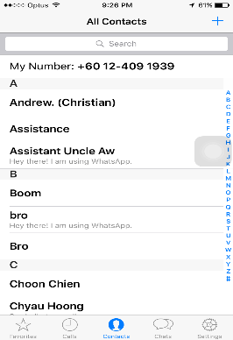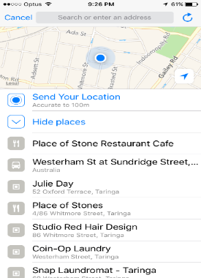

Chats (Home)

Contact List

Location Sharing

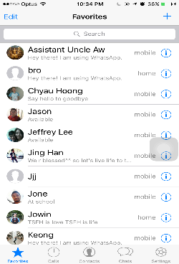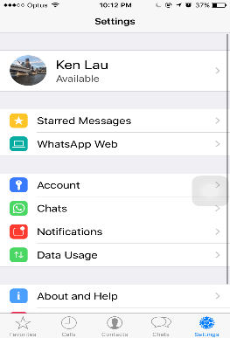

Favourites

Settings

**Description:** WhatsApp is one of most popular instant messaging app that has been intensively using by people for working and communication these days. It is multi-platform and encrypted instant messaging client for mobile devices. It is extremely good for sending text messages, documents video and so forth via internet or network.

**How to Use:**

1. Launching the app will brings users to the chat list.
2. There five main categories or tabs in the apps includes favourite, calls, contacts, chats and settings. To access all these categories, you have to press icon on bottom navigation bar to change activities.
3. The three main features of this app are to share location, chat, make phone call. Users able to create one-to-one or group conversations. The contact list can be automatically added from the local contacts in the device.
4. A notification that remind users the new message or location have been sent through chat. Users will be notified with call alerts when someone is calling via the app.
5. Opening notification will bring users to the page where the message, location sharing text or calls were located. Users can send their location to the people that are belongs to the particular chat session.
6. User can update their details such as the availability or account-related details through settings which is available on the app. The search

**Design & Interactivity**

**Positive**: There’s no splash screen or start-up pages make it easier to use as the users are not required to wait for the splash screen to be loaded. The tabbed host contains all four main categories is fairly well designed. The consistent use of colours and responsiveness of layout changes make it responsive to the users. The appropriate use of component model makes it looks better as the users are not confused and easily performed the activities. The navigation of activities is simple and can be done in just a few clicks. For instances, users can directly create a new chatting group by clicking the adding button and inviting the people that they want to add. Besides, the users can easily share their location by navigating optional bar. From there, users can share their location or nearby places if they want to.

**Negative**: The interactivity and responsive is incredibly good in this app. However, the app is not designed to categorize the type conversation such as one-to-one or group. They are all bundled together and the users can be easily confused and need to search it whether it is individual or group chat.

**Features & Functionality:**

**Positive**: One of interesting features available in this app is data tracking and usage. Users can turn on the low data usage when they are at outside or not at home. The features eliminate the unnecessary app that are not currently using. It can be saved up massive amount of network data and it is prolonging the device’s battery life. Most importantly, users can select and choose the type of documents they want to receive or send when WI-FI or cellular is available. The app has provided great and interactive map, including landmarks such as schools, parks or historical places. User can easily send their location by clicking the red popping icon shown in the map.

**Negative**: The app has pretty and fairly well designed features and its functionality.



Family Map – Location Tracking

**iTunes Store URL**: <https://itunes.apple.com/au/app/family-map-find-my-family/id1012640971?mt=8>

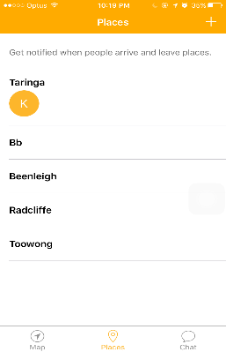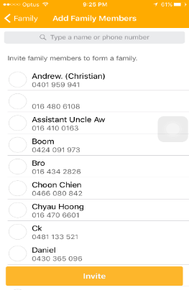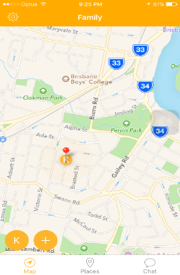**Screenshots:**

Place Alert

Home

Add Member

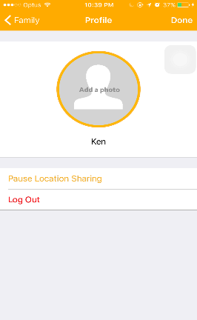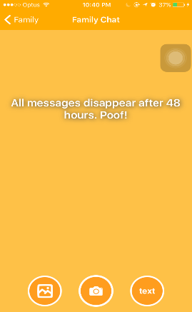

Setting

Chat

**Description:** Family Map is one of popular location-based app in mobile market these days. It has great and effective combination of techniques to determine the users’ location via phone. People usually use it to track safety or location of their families and friends around the world.

**How to Use:**

1. Launching the app brings up the splash screen and reminders of adding new member to the contact list in the app.
2. The interactive and multi-panning map appears after the splash screen is loaded. Pressing the icon with initial names will show the users the location of that particular person details.
3. New members can be added to the social circle by pressing the adding icon which is located on bottom-left of screen. The member belongs to the particular social circle can view location of everyone in the map.
4. Users can disable the location sharing feature to the member belongs to the particular social circles.
5. To access profile menu, users have to press the setting icon located on top-right of screen. The profile details can be updated from there as well.
6. User can create and save new place and get notified when members arrive or leave.
7. User can send the message in form of text, images or photos to the family chat by navigating to the chats. The members belong to the particular social circle will received the notification of message sent by others.

**Designs & Interactivity:**

**Positive**: The user interfaces and design is generally and fairly well designed. The navigation of activities such as swiping to the chatting sessions or adding new member is simple and easy to the user to perform task in just in seconds. The consistent use of yellow colour in most component model such as navigation bar, tabbed hosts, icon and selected theme make it looks better. The responsiveness of buttons and navigation bar make it more interactive to the users. It is simple and detailed with necessary and useful information to the users. Most importantly, the appropriate use of graphical animation and text customization make it looks even better and favourable.

**Negative**: However, the layout design and component arrangement designed in the family chat of the apps is slightly different. Its layout and design looks inconsistent and slightly different from the other component model in the app. The inconsistent design might not favourable to some users.

**Features & Functionality:**

**Positive**: The app provided great and interactive map, including surrounding landmarks such as park, schools or nearby restaurant. The users able to toggle between satellite, hybrid and interactive street maps for viewing options. The interactive map is integrated with map panning to let users make use of multi-touch interface to pan the map until they are finding the specific location of their families or friends.

**Negative**: Although family map is good and initially use to locate their family or friend’s location or safety, but it still has a few features that are not greatly designed. One of biggest challenges for this app is viewing or adding your own friends. The users are only allowed to find or locate their friend within contact list in their own phone. Users are not able to find or make new friends in the big social network until they know their contact number. They are not able to search or find people that they never know. The users are allowed to create only one social circle. The feature might be frustrating to some users who have bunch of friends or families and they want to split them into different group for easier communication.



Swarm – Location Sharing

**iTunes URL:** <https://itunes.apple.com/au/app/swarm-by-foursquare/id870161082?mt=8>

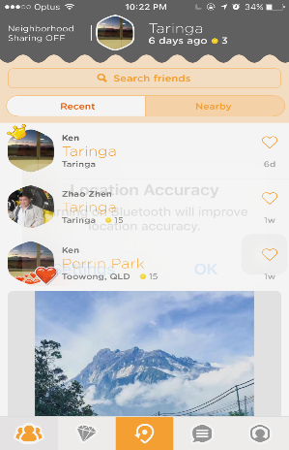**Screenshots:**

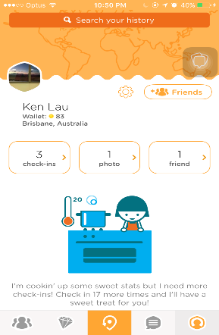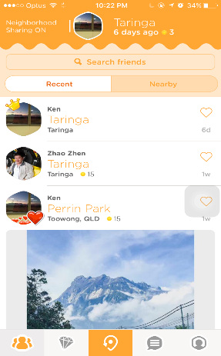

Home (History)

Neighbourhood (ON/ OFF)

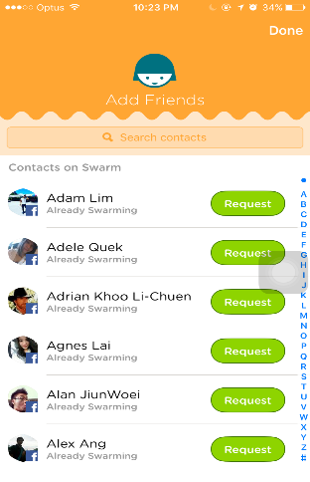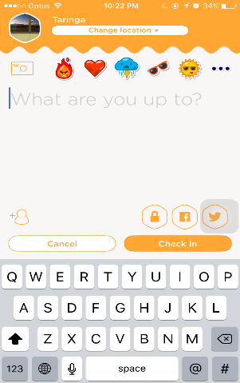

Add Friends

Check-ins

**Description:** Swarm is absolutely great location tracking app these days. It is available on iOS, Android and Windows to let users to share their locations to each other. It allows users to check-in to given location and let your own friend know and see who is nearby.

**How to Use:**

1. Launching the app will the bring users to the page which listing out all check-in activities of their friends.
2. Users can invite new friends who is currently available on the app through search bar located on the first tab in the bottom navigation bar.
3. Users are allowed to track their history along with the photo taken, chat messaging and all the past check-ins.
4. To receive the recent check-ins of friend, users are required to swipe down the screen of app.
5. Users will get notified when they are in range of required distance through the neighbourhood features. Users can turn it on or off to save up their devices’ battery life or data usage.
6. Users can check-in to the given location along with uploaded photos by pressing the third icon on bottom navigation bar.

Designs & Interactivity:

**Positive**: The appropriate use of component model and user interfaces is incredibly well designed in the app. The great use of graphical animation and text customization make it more attractive and favourable to the users who looks for interactive use. The opening page of swarm will display you a list of where your buddies are and also with your recent check-ins. It is easier to use as they are all arranged in chronological order with necessary details such as how long they have been away or check-in to given location.

**Negative**: The navigation of activities is not well designed in the app. Users are given multiple navigation to the particular or same activity as this might be frustrating or confusing to those users who are not familiarly good in using mobile devices. For instances, users are allowed to add friends through search bar or add friend’s icon which located on profile page. The icon design is not fairly well designed as there are no text display around the icon on navigation bar. The first-time users may not understand or familiar which tab should they pressed for the particular activities.

Features & Functionality:

**Positive**: It is one of great messaging, location sharing app and it was fun and trendy for a while. Users can easily search and find the person that they are looking for in just seconds. Users can check-in to given location and share it to their own friends or families from contact list. Besides, users can easily know how many people have publicly checked in to the location by clicking one of recent check-ins of their own friends. Furthermore, Swarms has great feature which allow users to broadcast the plan to the nearby friends who follow them on the app. However, they have to be in required range of distance to be notified who is nearby. Although users are not given to share their location within group chat but they can tag locations that currently stored in the Swarm database. It will link to small map along with the brief description of what are restaurant or landmarks at nearby. Users can start message with one-to-one or group conversation along with the feature of sharing photos and stickers.

**Negative**: Although it is great app for location sharing, but it also drains the battery life faster especially when the neighbourhood sharing feature is turned on. The feature will keep using your battery life as it runs on the background even you have completely exited the app. The users are required to turn on feature if they want to let their friends and families know where they have been up to. On the other hand, users are not given to share their location in the individual or group chat conversion within the app. They have to enter the current location by themselves along with location tags. This might be hard for those users who are not familiar to the city. To look at the entire venue details, the users are required to switch to the Foursquare app which is one of app that integrated with the Swarm. It allows the users to view nearby business location, landmarks and restaurant.